Machine Learning Project Based Learning (PBL) Report on
MOVE: AI for Stock Movement Explainability and Financial Literacy
Submitted in partial fulfilment of the
Requirements for the award of the degree of
BACHELOR OF TECHNOLOGY
In
COMPUTER SCIENCE AND ENGINEERING (AI&ML)

Submitted by
Kuppili Nikhilesh Raju 23R11A66H7
B. Nihanth 23R11A66F9

Under the esteemed guidance of
Mr. Shaik Akbar
Associate Professor, CSE(AI&ML) Department
Geethanjali College of Engineering and Technology



GEETHANJALI COLLEGE OF ENGINEERING AND TECHNOLOGY
Department of Computer Science and Engineering (AI&ML)
(UGC AUTONOMOUS INSTITUTION)
Accredited by NAAC with ‘A+’ Grade & Approved by AICTE and Affiliated to JNTUH Cheeryal
(V), Keesara (M), Medchal (Dist), Telangana – 501 301.

April – 2026


GEETHANJALI COLLEGE OF ENGINEERING AND TECHNOLOGY
Department of Computer Science and Engineering (AI&ML)
(UGC AUTONOMOUS INSTITUTION)
Accredited by NAAC with ‘A+’ Grade & Approved by AICTE and Affiliated to JNTUH Cheeryal
(V), Keesara (M), Medchal (Dist), Telangana – 501 301.

April – 2026
DEPARTMENT OF COMPUTER SCIENCE AND ENGINEERING (AI&ML)
CERTIFICATE
This is to certify that the Machine Learning Project Based Learning (PBL) Report entitled “MOVE: AI for Stock Movement Explainability and Financial Literacy” is a bonafide work done and submitted by Kuppili Nikhilesh Raju (23R11A66H7) and B. Nihanth (23R11A66F9) during the academic year 2025 – 2026, in partial fulfilment of the requirement for the award of Bachelor of Technology degree in “Computer Science and Engineering (AI&ML)” from Geethanjali College of Engineering and Technology (Accredited by NAAC with ‘A+’ Grade , Approved by AICTE and Affiliated to JNTUH), is a bonafide record of work carried out by them under guidance and supervision.
Certified further that to the best of my knowledge, the work in this project has not been submitted to any other institution for the award of any degree or diploma.

FACULTY GUIDE HOD-CSE(AIML)

Mr. Shaik Akbar Dr.A.Nageswara Rao

Associate Professor

CSE(AI&ML) Department

DECLARATION
We hereby declare that the project report entitled “MOVE: AI for Stock Movement Explainability and Financial Literacy” is an original work done and submitted to the CSE(AI&ML) Department, from Geethanjali College of Engineering and Technology (Accredited by NAAC with ‘A+’ Grade , Approved by AICTE and Affiliated to JNTUH), in partial fulfilment of the requirement for the award of Bachelor of Technology in “Computer Science and Engineering (AI&ML)” and it is a record of Bonafide project work carried out by us under the guidance of Mr. Shaik Akbar, Associate Professor, Department of CSE(AI&ML).
We further declare that the work reported in this project has not been submitted, either in part or in full, for the award of any other degree or diploma in this institute or any other Institute or University.

Signature of the Student
Kuppili Nikhilesh Raju
(23R11A66H7)

Signature of the Student
B. Nihanth
(23R11A66F9)

ACKNOWLEDGEMENT
This satisfaction of completing this project would be incomplete without mentioning our gratitude towards all the people who have supported us. Constant guidance and encouragement have been instrumental in the completion of this project.
First and foremost, we thank the Chairman, Vice Chairman, Director, Principal for availing infrastructural facilities to complete the project in time.
We offer our sincere gratitude to our faculty guide Mr. Shaik Akbar, Associate Professor, CSE(AI&ML) Department, from Geethanjali College of Engineering and Technology (Accredited by NAAC with ‘A+’ Grade , Approved by AICTE and Affiliated to JNTUH), for his immense support, timely co-operation and valuable advice throughout our project work.
We would like to thank the Head of Department, Dr. A. Nageswara Rao, for his meticulous care and co-operation throughout the project work.
We are thankful to all the project Coordinators for their supportive guidance and for having provided the necessary help for carrying forward this project without any obstacles and hindrances.

ABSTRACT
Move is an on-device artificial intelligence system designed to explain why a user’s stock or portfolio moved on a given day, instead of only showing price changes. The core motivation behind the project is that retail investors often see gains and losses in their brokerage applications but do not receive any structured explanation of the causes behind those movements. This lack of contextual understanding makes it difficult for users to learn from their investment behavior and improve financial decision-making over time.
The system combines market data, event analysis, factor attribution, and natural-language generation to create plain-language explanations for stock and portfolio movements. Rather than only displaying related headlines, Move attempts to identify and quantify likely drivers such as company earnings, sector-wide sentiment, foreign institutional investor activity, interest-rate changes, or macroeconomic announcements. These drivers are presented in ranked form so that the user can understand the relative contribution of each factor.
A major strength of the system is personalization. Move is designed to analyze the user’s own portfolio, trade history, and recurring behavioral patterns such as panic selling, overreaction to news, or holding losing positions for too long. Based on these patterns, the system generates lessons and suggestions that are more relevant than generic financial education content.
Another important aspect of the project is privacy. Since financial information is highly sensitive, Move is built with an on-device inference architecture in mind. Personalization, behavioral analysis, and language generation can run locally on AI-enabled consumer hardware, while public market data is fetched externally. This architecture improves privacy, reduces recurring inference cost, and supports multilingual delivery in English and major Indian languages.
Overall, the project demonstrates how machine learning, causal inference ideas, and edge AI can be combined to build a practical financial literacy assistant for India’s growing retail investor base.

LIST OF FIGURES

Figure.No. | Description | Pg.No.
6.1 | Why did your portfolio move? | 18
6.2 | Real-time Portfolio Feed | 18
6.3 | Stock Analyzer | 19
6.4 | AI Insight Summary | 19
6.5 | Fundamental Analysis | 20
6.6 | Technical Analysis | 20

TABLE OF CONTENTS

S.No. | Contents | Pg.No.
1 | Introduction | 1
2 | Literature Survey | 4
3 | System Requirement Specifications | 6
4 | Implementation | 7
5 | Sample Code | 10
6 | Output Screens | 28
7 | Conclusion | 21
8 | Future Scope | 22
9 | Bibliography | 23

INTRODUCTION
1.1 Background
India is experiencing rapid growth in retail investing, with millions of first-time investors entering the market through mobile brokerage platforms. While access to investing has become easier, understanding market movement remains difficult for most users. Investors can quickly see that a stock has fallen or that their portfolio is down, but they are rarely told why this happened in a clear, structured, and personalized manner.
This creates an important educational gap. If a person buys a stock and it drops sharply, the loss alone does not teach the investor whether the reason was earnings disappointment, broader sector weakness, macroeconomic pressure, global yields, institutional selling, or temporary volatility. Without such explanations, users may repeat the same mistakes and continue making decisions based on fear, rumors, or unreliable market commentary.
Move is proposed as a solution to this problem. It is a mobile-first and on-device AI assistant that explains stock and portfolio movement in simple language, quantifies likely causes, and converts each market event into a learning opportunity.

1.2 Existing Systems
Several categories of systems currently exist in the investing ecosystem. News platforms such as Moneycontrol or ET Markets provide a constant stream of headlines and updates. Brokerage applications such as Zerodha, Groww, Angel One, and Upstox provide market access, charting, and transaction execution. Educational platforms such as Varsity explain investing concepts, while premium institutional tools like Bloomberg Terminal provide advanced analytics to professional users.
Although each of these systems solves part of the user’s problem, they do not close the complete feedback loop between portfolio movement and investor learning. News applications provide information but not quantified attribution. Broker applications show prices and returns but do not explain the causes of those returns. Educational platforms teach concepts in general terms but do not connect them to the user’s own portfolio in real time. Institutional tools are too expensive and complex for typical retail investors.

1.3 Limitations of Existing Systems
The main limitation of current systems is that they do not answer the most important user question after a loss: “Why did this happen to my portfolio today?” Most products either provide raw numbers or unrelated news, leaving the user to manually guess the real cause.
Another limitation is the absence of behavioral feedback. Existing tools rarely detect whether a user is repeatedly panic selling, reacting too strongly to news, or making short-term decisions that harm long-term performance. As a result, there is no personalized learning loop.
Privacy is also a major concern. If a highly personalized assistant is built entirely in the cloud, the user’s portfolio, trading history, and behavior patterns become centralized data assets. This raise concerns around data trust, cost, and platform dependency.

1.4 Proposed System
The proposed system, Move, is an explainability-focused financial intelligence assistant. Its purpose is to understand market movement at three levels: the stock level, the portfolio level, and the behavioral level.
At the stock level, it identifies the main events and factors responsible for a price move and assigns approximate contribution percentages. At the portfolio level, it determines which holdings contributed most to the daily gain or loss and connects those movements to relevant external events. At the behavioral level, it identifies repeated user actions and links them to past outcomes, enabling financial literacy through contextual feedback.
The solution combines statistical methods, factor decomposition, retrieval-augmented explanation generation, and local personalization. The final explanation is delivered in the user’s preferred language and is written in simple terms rather than financial jargon.

1.5 Advantages of Proposed System
The proposed system offers several advantages over existing products:
- It explains causes instead of only showing prices.
- It personalizes insights to the user’s own holdings and decisions.
- It supports multilingual output, making explanations accessible to a broader investor base.
- It is designed for privacy through on-device inference.
- It converts portfolio changes into financial literacy lessons rather than isolated alerts.
- It provides a practical bridge between AI, quantitative analysis, and real-world retail investing.

1.6 Aim and Objectives
Aim
To develop an on-device AI system that explains stock and portfolio movement, quantifies probable drivers, personalizes insights to the user’s investment behavior, and improves financial literacy through contextual explanations.
Objectives
- To collect and integrate stock, macroeconomic, and news-event data relevant to portfolio movement.
- To identify important market and event-driven factors affecting stock returns.
- To build a causal attribution engine that estimates the contribution of different factors to price movement.
- To personalize explanations based on the user’s portfolio and trade history.
- To detect behavioral patterns such as panic selling and overtrading.
- To generate explanations in simple natural language using an LLM-based summarization layer.
- To support multilingual delivery for Indian users.
- To design the system with on-device privacy and low inference cost in mind.

2.LITERATURE SURVEY

2.1 AI in Financial Market Analysis

Financial markets generate high-volume, time-sensitive, and event-driven data. Prior research and industry systems show that machine learning can be used for forecasting, anomaly detection, factor analysis, and event interpretation. However, prediction accuracy alone is not enough for user learning. In retail investing, explanation is as important as prediction because users need to understand what caused the movement rather than simply receiving a directional output.
This project builds on the broader idea that machine learning in finance should not only optimize models but also improve interpretability for non-expert users.

2.2 Event Study and Factor-Based Attribution

A common approach in financial analytics is the event study method, where price reactions are analyzed around announcements such as earnings, policy changes, or macroeconomic news. Factor-based approaches decompose asset returns into components such as market return, sector performance, style exposure, and macro sensitivity.
These methods are relevant to Move because the system aims to separate broad market movement from stock-specific and event-specific movement. Instead of providing a vague explanation, the project attempts to rank multiple factors and estimate their influence on a specific stock or portfolio move.

2.3 Explainable AI in Finance

Explainable AI has become increasingly important in domains where decisions affect money, risk, or trust. In finance, users are less likely to rely on a system if it produces outputs without supporting reasoning. Modern financial assistants therefore need interpretable outputs, source-grounded explanations, and transparent cause summaries.
Move applies this principle by combining statistical analysis with natural-language explanation generation. Quantitative techniques provide the structure, while language models convert that structure into readable explanations.
2.4 Personalized Recommendation and Behavior Analysis

Many digital platforms now use personalization to adapt recommendations to user behavior. In financial applications, personalization can go beyond content ranking and include user-specific lessons derived from trading behavior. For example, repeated panic exits after volatile sessions may indicate a behavior pattern that causes avoidable losses.
This idea is highly relevant to Move, since the system is intended to become more useful as it learns from the investor’s own actions over time.

2.5 Edge AI and On-Device Inference

On-device AI has become practical due to improvements in consumer hardware acceleration, efficient transformer models, quantization, and runtime optimization. Running inference locally offers two strong benefits for this project: privacy of portfolio data and lower recurring cost compared with cloud-only AI.
Move extends this trend into finance by proposing a hybrid architecture in which public market data can be processed externally, while user-specific inference remains local.

2.6 Comparative View of Existing Approaches
S.No. | Focus Area | Common Method | Relevance to Move | Limitation in Existing Use
1 | Financial news analysis | Headline aggregation | Useful for event signals | Does not quantify causality
2 | Return decomposition | Factor models | Useful for attribution | Often not user friendly
3 | Explainable AI | Model interpretation | Useful for trust and learning | Rarely tailored to retail investors
4 | Personalization systems | User behavior modeling | Useful for investor-specific lessons | Often ignores privacy
5 | Edge AI systems | On-device inference | Useful for low-cost private AI | Rarely applied to investing explainability
3.SYSTEM REQUIREMENT SPECIFICATIONS

3.1 HARDWARE REQUIREMENTS
- Processor: AMD Ryzen AI enabled processor is preferred for local inference and optimized edge deployment.
- RAM: Minimum 8 GB RAM; 16 GB recommended for smoother model execution and local data processing.
- Storage: At least 2 GB free storage for project files, cached market data, models, and logs.
- Display: Standard laptop or desktop display is sufficient for dashboard and analytics visualization.
- Internet Connectivity: Required for fetching public market data, filings, and macroeconomic updates.

3.2 SOFTWARE REQUIREMENTS
- Operating System: Windows, Linux, or macOS.
- Programming Language: Python.
- Frontend / Interface: React Native for mobile or Streamlit/Electron for prototype demonstrations.
- Backend Framework: FastAPI for APIs and orchestration.
- Database: PostgreSQL for historical market data and Redis for caching.
- Machine Learning Libraries: Scikit-learn, PyTorch, NumPy, Pandas.
- LLM / Inference Runtime: ONNX Runtime with quantized language models for edge deployment.
- Visualization: Plotly or similar libraries for trends, attribution charts, and portfolio explainers.
- Development Tools: VS Code, Jupyter Notebook, Git
4.IMPLEMENTATION
4.1 Understanding the Problem
The central problem addressed by this project is not merely stock prediction but stock movement explanation. In most retail investing systems, users can observe portfolio movement but cannot distinguish between noise and meaningful causes. This creates confusion, poor learning, and behavioral mistakes.
The implementation therefore focuses on identifying explainable drivers behind movement and translating them into personalized insights. The system must answer questions such as: Which events mattered most today? Which holdings caused the portfolio decline? Did the user react similarly in the past? Was the move driven by company-specific or broad-market factors?

4.2 Model and System Explanation
The system can be understood as a four-layer architecture:
1. Data Ingestion Layer
This layer collects stock prices, index movements, sector trends, earnings updates, company filings, FII/DII flows, macro announcements, and selected public sentiment indicators.
2. Causal Inference and Attribution Layer
This layer runs event-study style analysis, factor decomposition, and significance estimation around major price moves. The goal is to estimate which drivers best explain the observed change in stock or portfolio value.
3. Personalization Layer
This layer uses the user’s local portfolio data, trade history, and action sequences to identify repeated patterns such as panic selling, overtrading after news, or concentration risk. This information is stored and processed locally for privacy.
4. Explanation Delivery Layer
This layer converts quantitative attribution into readable summaries in the user’s preferred language. It presents outputs through Why Cards, Loss Ledger entries, and event explainers.

4.3 Technologies Used
Python
Python is used as the primary language because it supports machine learning, data pipelines, API development, and rapid prototyping.
Pandas and NumPy
These libraries are used for market data handling, preprocessing, numerical operations, and event-window preparation.
Scikit-learn / PyTorch
These frameworks are used for factor analysis support models, behavioral sequence models, and predictive components.
FastAPI
FastAPI is suitable for building efficient service endpoints for data access, orchestration, and modular deployment.
PostgreSQL and Redis
PostgreSQL stores structured market and event data, while Redis is used for fast caching of frequently accessed signals.
ONNX Runtime / Quantized LLM
A compact language model is used to transform structured attribution output into plain-language explanations that can run on-device.
React Native / Electron / Streamlit
These technologies can be used for prototype UI development depending on whether the target environment is mobile, desktop, or demo-ready web delivery.

4.4 System Workflow
The overall workflow of Move is as follows:
- Public market and event data are collected from external sources.
- Market signals are cleaned and aligned to stock and sector timelines.
- Significant stock or portfolio moves are identified.
- Event-study and factor attribution logic estimate possible causes.
- User portfolio and behavior data are analyzed locally.
- A personalization engine links movement to the user’s holdings and prior actions.
- An LLM-based explanation layer generates simple-language output.
- The final explanation is shown as a Why Card, Loss Ledger note, or event alert.

4.5 Output
The system is designed to produce the following outputs:
- A daily portfolio movement summary.
- Ranked causal drivers with percentage contribution.
- Position-level impact on the portfolio.
- Behavioral alerts based on historical user actions.
- Plain-language explanations in English or Indian regional languages.
- Event-triggered explainers for major announcements such as Budget, RBI policy, or earnings.

5.SAMPLE CODE
5.1 Backend — move_backend/main.py
from fastapi import FastAPI
from fastapi.middleware.cors import CORSMiddleware
from routes import portfolio, explain, events, literacy

app = FastAPI(title="Move API", version="1.0.0")

app.add_middleware(
CORSMiddleware,
allow_origins=["*"],
allow_methods=["*"],
allow_headers=["*"],
)

app.include_router(portfolio.router, prefix="/api/portfolio")
app.include_router(explain.router, prefix="/api/explain")
app.include_router(events.router, prefix="/api/events")
app.include_router(literacy.router, prefix="/api/literacy")

@app.get("/")
def root():
return {"status": "Move API is running"}

5.2 routes/explain.py — Why Card endpoint
from fastapi import APIRouter, HTTPException
from models.portfolio import PortfolioRequest
from services.causal_engine import explain_portfolio_move

router = APIRouter()

@router.post("/why-card")
async def get_why_card(request: PortfolioRequest):
try:
result = await explain_portfolio_move(
holdings=request.holdings,
date=request.date,
language=request.language
)
return {"status": "success", "why_card": result}
except Exception as e:
raise HTTPException(status_code=500, detail=str(e))

5.3 models/portfolio.py
from pydantic import BaseModel
from typing import List, Optional

class Holding(BaseModel):
symbol: str # e.g. "TCS.NS"
quantity: int
avg_buy_price: float

class PortfolioRequest(BaseModel):
user_id: str
holdings: List[Holding]
date: str # "2025-07-01"
language: str = "en" # "en", "hi", "te", "ta", "bn"

class CausalFactor(BaseModel):
factor: str # "FII outflows", "Accenture guidance"
contribution_pct: float
direction: str # "up" | "down"
explanation: str

class WhyCard(BaseModel):
date: str
total_pnl: float
portfolio_change_pct: float
top_factors: List[CausalFactor]
behavioral_alert: Optional[str]
summary: str # Plain language in user's chosen language

5.4 services/causal_engine.py — Core attribution logic
import numpy as np
import pandas as pd
from services.market_data import fetch_price_data, fetch_macro_data
from services.llm_explainer import generate_explanation
from models.portfolio import WhyCard, CausalFactor

async def explain_portfolio_move(holdings, date, language="en") -> WhyCard:
symbols = [h.symbol for h in holdings]

# Fetch price data for the date
price_data = await fetch_price_data(symbols, date)
macro_data = await fetch_macro_data(date)

# Calculate portfolio P&L
total_pnl = sum(
h.quantity * price_data[h.symbol]["change"]
for h in holdings
if h.symbol in price_data
)

# Factor decomposition (simplified event-study)
factors = decompose_returns(price_data, macro_data, holdings)

# Generate LLM explanation in user's language
summary = await generate_explanation(factors, total_pnl, language)

return WhyCard(
date=date,
total_pnl=round(total_pnl, 2),
portfolio_change_pct=round(sum(f.contribution_pct for f in factors), 2),
top_factors=factors,
behavioral_alert=None,
summary=summary
)

def decompose_returns(price_data, macro_data, holdings) -> list:
"""
Simplified factor attribution:
- Market beta (Nifty movement)
- Sector factor (e.g. IT index vs Nifty)
- FII/DII flow impact
- Macro (rupee, US 10Y yield)
- Residual / stock-specific
"""
factors = []

nifty_change = macro_data.get("nifty_change", 0)
fii_flow = macro_data.get("fii_net_flow", 0)
inr_change = macro_data.get("inr_usd_change", 0)

# Market factor
if abs(nifty_change) > 0.3:
factors.append(CausalFactor(
factor="Broad market movement (Nifty 50)",
contribution_pct=round(nifty_change * 0.55, 2),
direction="down" if nifty_change < 0 else "up",
explanation=f"Nifty moved {nifty_change:.2f}% driving most of portfolio"
))

# FII flows
if fii_flow < -2000: # crore
factors.append(CausalFactor(
factor="FII outflows",
contribution_pct=round(nifty_change * 0.25, 2),
direction="down",
explanation=f"Foreign investors sold ₹{abs(fii_flow):.0f} cr today"
))

# Currency impact (for IT stocks)
if abs(inr_change) > 0.2:
factors.append(CausalFactor(
factor="Rupee movement vs USD",
contribution_pct=round(inr_change * 0.15, 2),
direction="down" if inr_change > 0 else "up",
explanation=f"INR {'strengthened' if inr_change > 0 else 'weakened'} by {abs(inr_change):.2f}%"
))

return factors

5.5 services/llm_explainer.py — On-device LLM (Ryzen AI)
from core.llm_runner import run_local_llm

LANGUAGE_PROMPTS = {
"en": "Explain in simple English for a retail investor:",
"hi": "एक सामान्य निवेशक के लिए सरल हिंदी में समझाएं:",
"te": "ఒక సాధారణ పెట్టుబడిదారుకు సరళమైన తెలుగులో వివరించండి:",
"ta": "ஒரு சாதாரண முதலீட்டாளருக்கு எளிய தமிழில் விளக்கவும்:",
}

async def generate_explanation(factors, total_pnl, language="en") -> str:
lang_instruction = LANGUAGE_PROMPTS.get(language, LANGUAGE_PROMPTS["en"])

factor_text = "\n".join([
f"- {f.factor}: {f.contribution_pct:.1f}% ({f.direction}). {f.explanation}"
for f in factors
])

prompt = f"""
{lang_instruction}

Your portfolio moved by ₹{total_pnl:.0f} today due to these factors:
{factor_text}

Write a 3-sentence explanation that:
1. States the total loss/gain clearly
2. Names the top 2 causes in plain language
3. Tells the investor whether their stocks are fundamentally impaired

Keep it under 80 words. No jargon.
"""

response = await run_local_llm(prompt)
return response.strip()

5.6 services/market_data.py — NSE/BSE data fetch
import httpx
import yfinance as yf
from datetime import datetime

async def fetch_price_data(symbols: list, date: str) -> dict:
result = {}
for symbol in symbols:
try:
ticker = yf.Ticker(symbol)
hist = ticker.history(start=date, end=date, interval="1d")
if not hist.empty:
row = hist.iloc[0]
result[symbol] = {
"open": row["Open"],
"close": row["Close"],
"change": ((row["Close"] - row["Open"]) / row["Open"]) * 100
}
except Exception:
result[symbol] = {"open": 0, "close": 0, "change": 0}
return result

async def fetch_macro_data(date: str) -> dict:
# In production: pull from NSE API, RBI, NSDL FII data
# Sample stub for development
return {
"nifty_change": -1.8,
"fii_net_flow": -3400, # crore
"dii_net_flow": 1200,
"inr_usd_change": 0.3, # rupee strengthened 0.3%
"india_vix": 14.2,
"us_10y_yield_change": 0.05
}

5.7 agents/behavioral_agent.py — Pattern detection
from models.portfolio import Holding
from typing import List

PATTERNS = {
"panic_sell": "You sold during a dip and missed the recovery {n} times in the past year.",
"overtrade": "You made {n} trades in the past 7 days — above your average of {avg}.",
"hold_loser": "You've held {symbol} at a loss for {days} days. Historical avg recovery: {recovery_days} days.",
}

def detect_behavioral_patterns(user_id: str, trade_history: list) -> list[str]:
alerts = []

# Check panic selling pattern
panic_count = sum(
1 for t in trade_history
if t["action"] == "sell" and t["pnl_pct"] < -3
and was_followed_by_recovery(t)
)
if panic_count >= 2:
alerts.append(PATTERNS["panic_sell"].format(n=panic_count))

# Check overtrading
recent_trades = [t for t in trade_history if days_ago(t["date"]) <= 7]
avg_weekly = len(trade_history) / max(len(trade_history) / 7, 1)
if len(recent_trades) > avg_weekly * 1.5:
alerts.append(PATTERNS["overtrade"].format(
n=len(recent_trades),
avg=round(avg_weekly, 1)
))

return alerts

def was_followed_by_recovery(trade: dict) -> bool:
# Stub: check if stock recovered >5% in 30 days after sell
return trade.get("post_sell_30d_change", 0) > 5

def days_ago(date_str: str) -> int:
from datetime import datetime
d = datetime.strptime(date_str, "%Y-%m-%d")
return (datetime.now() - d).days

5.8 requirements.txt
fastapi==0.111.0
uvicorn==0.29.0
pydantic==2.7.0
httpx==0.27.0
yfinance==0.2.37
pandas==2.2.2
numpy==1.26.4
transformers==4.40.0
onnxruntime==1.17.3
python-dotenv==1.0.1

5.7 Steps Followed for Implementation
- Problem definition and objective setting.
- Identification of important stock movement drivers.
- Selection of data sources and feature categories.
- Design of event-study and factor attribution pipeline.
- Design of behavior-tracking and personalization layer.
- Integration of on-device explanation generation.
- Development of dashboard or app prototype.
- Testing of explanation quality, personalization quality, and usability.

6.OUTPUT SCREENS
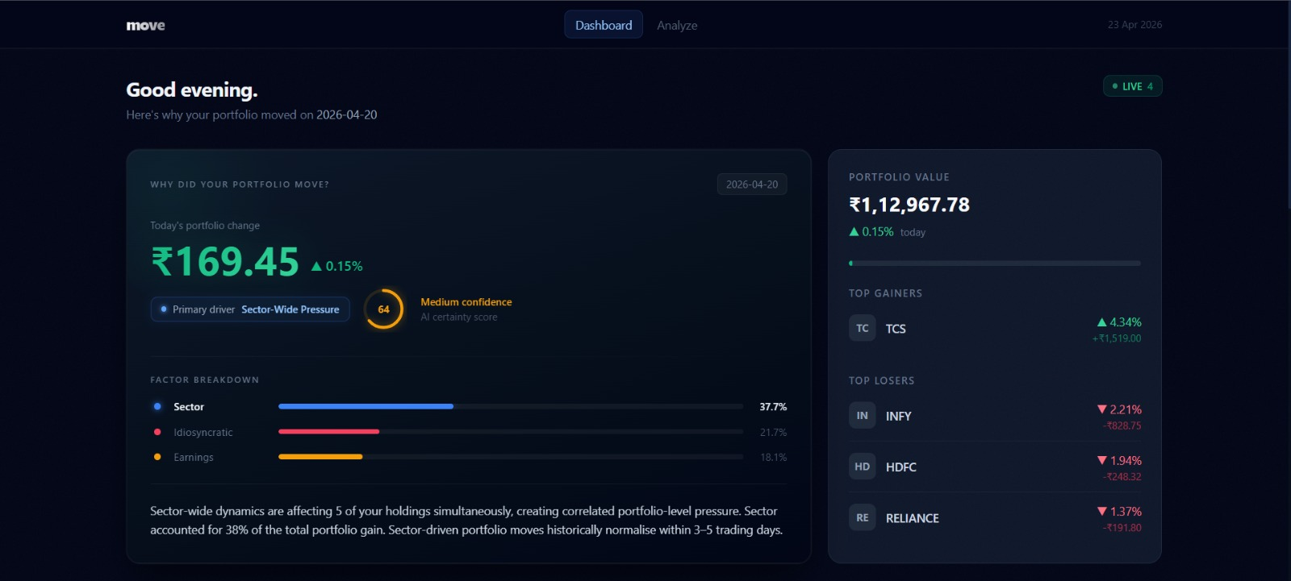
Figure 6.1: Why did your portfolio move?
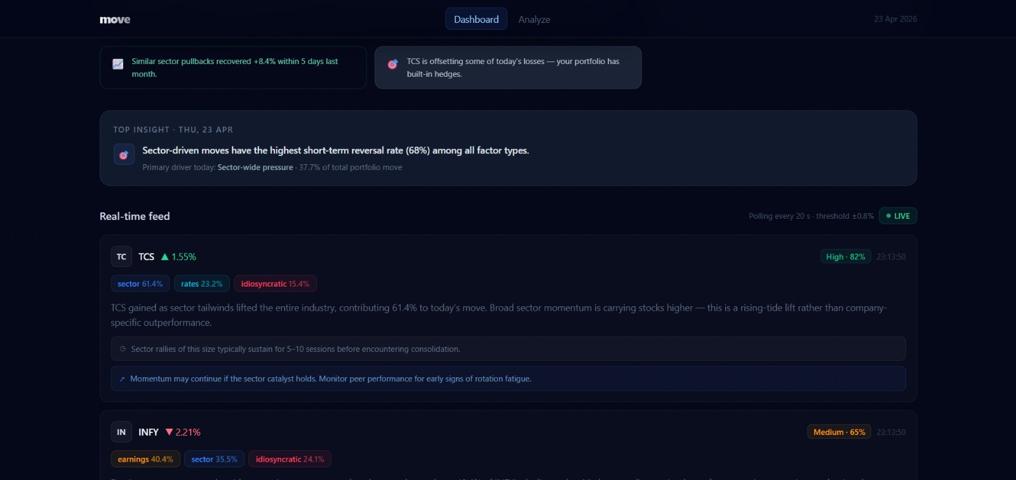
Figure 6.2: Real-time Portfolio Feed
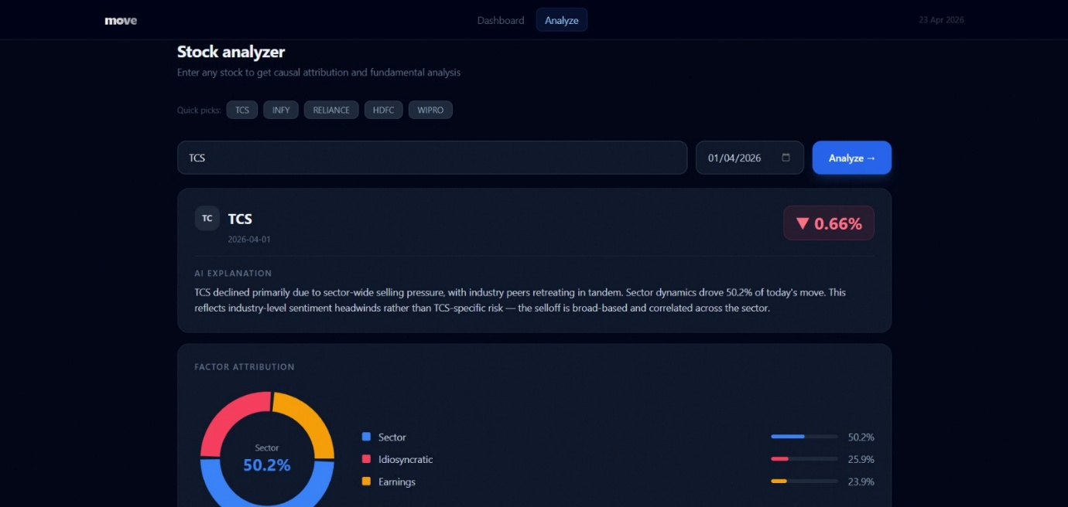
Figure 6.3: Stock Analyzer
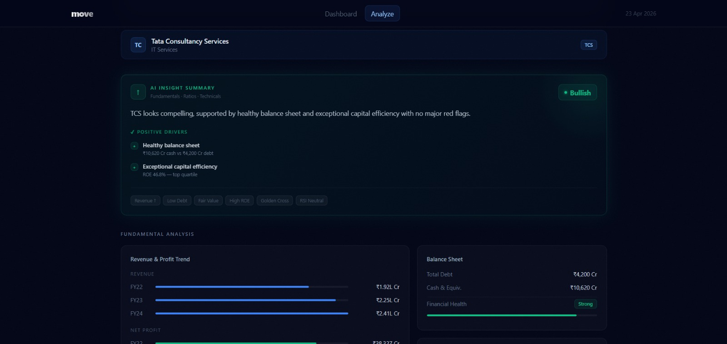
Figure 6.4: AI Insight Summary
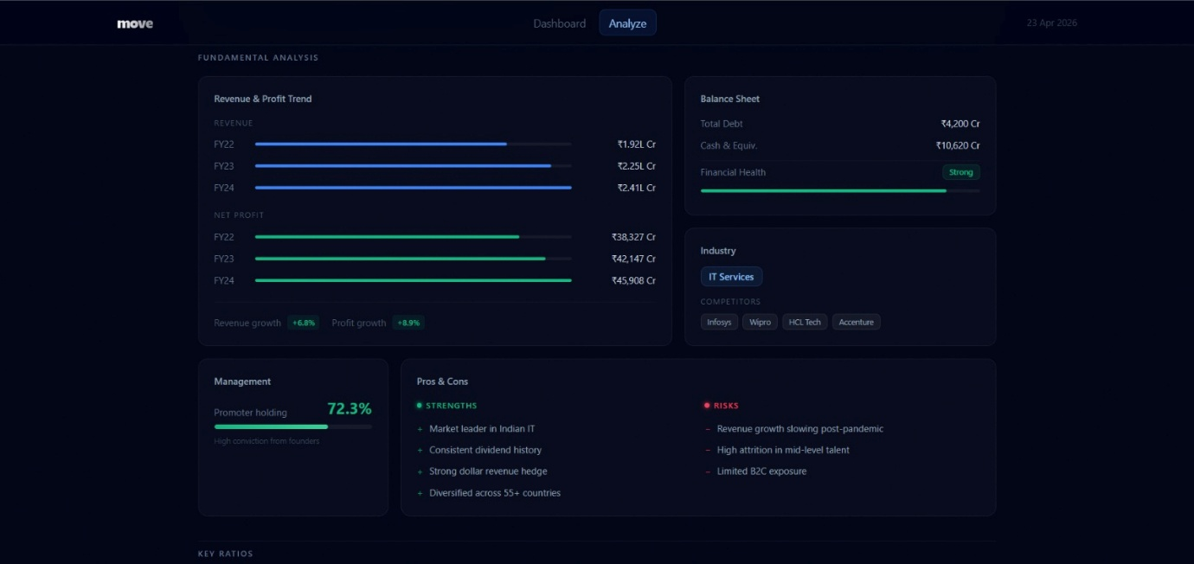
Figure 6.5: Fundamental Analysis
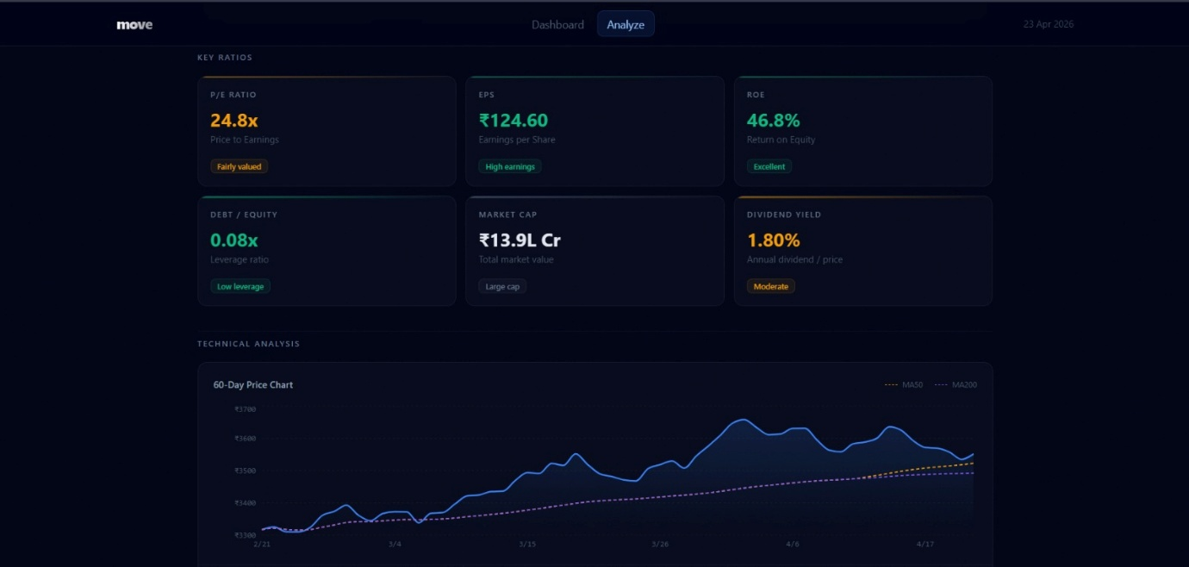
Figure 6.6: Technical Analysis

7.CONCLUSION
This project presents Move as a financial explainability system designed for the next generation of Indian retail investors. The key contribution of the system is that it moves beyond simply showing stock prices and portfolio values, and instead focuses on identifying and communicating the likely reasons behind those movements.
By combining event analysis, factor attribution, personalization, and on-device AI, the system creates a more meaningful investing experience. Users are not only informed about losses and gains but are also given context, interpretation, and behavioral feedback that can help them make better decisions over time.
Another important contribution is the privacy-first architecture. Since investor data is highly sensitive, the use of local inference offers an attractive alternative to cloud-only financial assistants. This makes the system both technically relevant and practically valuable.
Overall, Move demonstrates how machine learning can be applied not only for prediction but also for explanation, education, and trust-building in financial technology.

8.FUTURE SCOPE
The following improvements can be considered in future versions of the project:
- Expansion from a small stock universe to the full Nifty 500 and beyond.
- Integration with live broker APIs for direct portfolio synchronization.
- Better causal inference with richer factor libraries and event knowledge graphs.
- Stronger behavioral modeling using sequence learning techniques.
- More accurate multilingual explanation generation for Indian regional languages.
- Explainability for mutual funds, ETFs, and derivatives.
- WhatsApp-based alert delivery and conversational querying.
- Institutional and broker-facing versions of the Why Engine.

9. BIBLIOGRAPHY
- Research articles and technical resources on financial event studies, factor models, explainable AI, and on-device inference.
- Documentation for Python, Pandas, NumPy, Scikit-learn, PyTorch, FastAPI, and ONNX Runtime.
- Public resources on Indian stock market structure, brokerage platforms, and financial literacy trends.
- Product concept notes and architecture planning for Move.
- Attached report structure used as the documentation template reference.

